
Common Security Module
CSM GAARDS User Migration (CGMM)
Design Document

Version No: 1.0
Last Modified: 08/06/2008

Author : Vijay Parmar
Team : Common Security Module
Purchase Order # 34552
Client : National Cancer Institute - Center for Bioinformatics,
National Institutes of Health,
US Department of Health and Human Services

Document History

Document Location
The most current version of this document is located in CVS under security/docs/CSM 4.1/development/design.

Revision History
Version Number | Revision Date | Author | Summary of Changes
0.1 | 07/11/2008 | Vijay Parmar | Initial Draft
0.2 | 07/31/2008 | Vijay Parmar | Provide interaction detail amongst all components of the migration module
1.0 | 8/05/2008 | Vijay Parmar

Review
Name | Team/Role | Version | Date Reviewed | Reviewer Comments
Charles Griffin | Project Manager | 1.0 | 08/06/2008
Kunal Modi | Security Solution Architect | 1.0 | 08/06/2008
Satish Patel | caCORE SDK Lead | 1.0 | 08/06/2008

Related Documents
More information can be found in the following related CSM documents:

Document Name
Security Solutions Arch 1 Document

Table of Contents

1. Introduction 5
1.1 Problem Scenario 5
1.2 Scope 5
2. Requirement Analysis 6
2.1 Requirements 6
2.1.1 Business Requirements 6
2.1.2 Technical Requirements 6
2.1.3 Policy Requirements 7
2.2 Assumptions 7
2.3 Dependencies 7
2.4 Known Issues or Future Considerations 7
2.5 Technical Environment 7
3. Detail Design 9
3.1 Overview 9
3.2 Components of CSM GAARDS User Migration Module 10
3.3 Workflows 11
3.3.1 CGMM Workflow 11
3.3.2 CGMM User Interface Workflow 15
3.4 Interaction with GAARDS 16
3.4.1 SyncGTS 16
3.4.2 Interaction with Authentication Service 16
3.4.3 Interaction with Dorian 16
3.4.4 Validation of Proxy 17
3.5 Interaction between CGMM and Host application 18
3.5.1 Interaction between Filter and Host application 18
3.5.2 Interaction between CGMM and Filter 19
3.5.3 Session Attributes 20
3.5.4 Required changes in Host Application 21
3.6 Configuration 21
3.6.1 Overview 21
3.6.2 CGMM Feature configuration 21
3.6.3 User Interface Configuration 22
3.6.4 GAARDS Configuration 23
3.6.5 Sync GTS configuration 23
3.7 Database Change 23
3.8 Deployment 24
3.8.1 Deployment Diagram 24
3.8.2 Deployment Considerations 24
4. Unit Testing 25
4.1 JUnit Test Cases 25
4.2 Test Case Scenarios 25

Introduction

The Common Security Module (CSM) was chartered to provide a comprehensive solution to common security objectives, so not all development teams need to create their own security methodology. caGrid is the underlying service oriented infrastructure that supports caBIG. The Grid Authentication and Authorization with Reliably Distributed Services (GAARDS) provides services and tools for the administration and enforcement of security policy in an enterprise Grid. GAARDS was developed on top of the Globus Toolkit and extends the Grid Security Infrastructure (GSI) to provide enterprise services and administrative.

Problem Scenario

The existing web applications use CSM for authentication and authorization. Using CSM, these existing applications have been able to authenticate the application users against local Institution Credential Provider (CP) also known as Identity Provider - IdP.

The existing web applications are increasingly hosting caGrid services that require Grid based authentication. Hence the user base includes local and Grid users. With the adoption of caBIG and growing user base, the existing web applications are supporting or would like to support additional Credential Providers including Grid supported Identity Providers and their users. The existing users of the web applications also have or need to have Grid credentials. It is difficult to maintain and provision users with two different authentication methods.

Currently, there are no tools available to assist existing web applications to automatically migrate users with CSM credentials to Grid credentials. Also currently to provision user security the existing web applications has to
1) Provision twice for each user; namely the user’s CSM Local Account and Grid Account or
2) Manually update CSM user to Grid user account.
For applications with large user base such solutions are not scalable and create a difficult maintenance effort.

The CSM GAARDS User Migration Module (CGMM) provides a solution to above issues, it automates the process of migrating the CSM users to Grid users.

Scope

This document details the design for the CSM-GAARDS User Migration Module. It provides detail design and integration design with an existing Host application using CSM for authentication and authorization. This document doesn’t provide design details about the Host application and describes integration points necessary to for the solution to work. The Host application details and design are beyond the scope of this document.

Requirement Analysis

Requirements

Business Requirements
- Single Set of Credentials

The existing web applications having CSM based authentication is required to provide Grid based authentication. Hence users with CSM credentials as well as Grid credentials can access all components of existing web application.
The requirement is to avoid duplication of accounts for existing and new users. The application needs to provide a single set of credentials to access various above mentioned components.

- GAARDS based authentication

The requirement is to switch CSM based authentication to caGrid’s GAARDS based authentication. Users should not be allowed to login using CSM credentials once they are migrated.

- Migrate Accounts

The Migration module will enable migrating of existing users accounts from CSM accounts to Grid accounts. This will make users authenticated against GAARDS for scalability and federation.

- Provisioning of new users with Grid Identities.

New users should be allowed to create Grid accounts and login to existing application using Grid credentials. The existing applications Authorization policy provisioning should be enhanced to allow users Grid Identities instead of CSM credentials.

Technical Requirements

- Seamless integration of Migration Module with existing web application

The Migration Module should be integrated with minor modifications to the Host application

- Configurable Look and Feel

The Migration Module web application should be configurable to allow the Host web application to plug in their look and feel. The Migration module web application should support the look and feel available in current NCICBIIT web application Templates.

- Configurable CaGrid Identity Providers for Authentication

The Migration Module web application should allow authentication of Users against a configurable list of Identity Providers (Authentication Services) and their corresponding Dorian URL’s. The configuration shall be made via an external properties file for the Migration Module application.

- Migration Module supports cagrid 1.2
caGrid 1.2 is supported and the migration module will use Authentication and Dorian Services created using caGrid 1.2.

Policy Requirements

To use caBIG approved Identity Providers and thus allowing federation of identity
The web application should use a caBIG approved Identity Provider as your credential source. This way any user which is member of those Identity Providers can log onto the application (provided the user has appropriate access permission if any).

Assumptions
- Migration Module and Migration Host application reside on same Application Server.
- The Migration Host application has a New Local User Create Module/Implementation/Workflow.
- Tomcat clustering is not done.
- The Application Server hosting the web applications has the host CA credentials to establish communication with Authentication Service and Dorian Service.
- The Maximum length of Grid ID is 1000 characters.
- The Grid proxy or Grid Identity shouldn’t be persisted when passing control between the Migration Module and Host web application.

Dependencies

- CaGrid 1.2 – Authentication Service, Dorian, SyncGTS.

CGMM depends on the caGrid v1.2 for the client API’s of Authentication Service, Dorian and SynGTS

- CSM v4.1 and CSM UPT v4.1

The Host application will need to upgrade to CSM API v4.1 and CSM UPT v4.1 to leverage the new features implemented for the CGMM.

Known Issues or Future Considerations

- The Migration Module is designed with the assumption that the Host application has existing New CSM user creation and provisioning Workflow for authorization, to which the Migration Module will pass control over to as part of the New user CSM Create Use case.
- The length of Grid Identity is not bounded in CaGrid. In CSM it is bounded to 1000 characters.

Technical Environment
- Client Interface
  - Internet Explorer 6.0 and above
  - Mozilla v1.5.0.3 and above (if possible)
- Application Server
  - Apache Tomcat 5.0.28
  - JBoss 4.0.5
- Operating system
  - Windows XP
  - Linux/Unix
- Java 1.5
- Globus Toolkit 4.0.3
- caGrid Release v1.2

Detail Design

Overview

This following section describes the solution designed for CSM GAARDS Migration Module (CGMM) and integration with Host application.

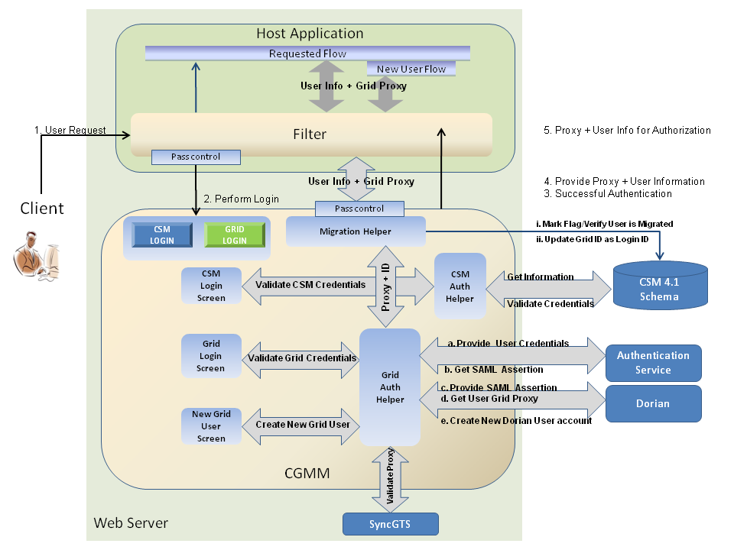
Figure 1: CGMM Design

The above diagram demonstrates the components and their interactions at a high level. As shown in the figure 1, CGMM is a web application that is hosted on the same application server as the Host web application. The Host application uses a migration Filter ‘CGMMMigrationFilter’ that is provided by the CGMM. The GAARDS components used are Authentication Service, Dorian Service and SyncGTS.

The overall flow for CGMM is as following
- A user accesses Host applications secured page.
- An Http filter intercepts the user’s request. The filter checks the session for user information attributes to verify if a user is logged in or not. If user is not logged in then the filter routes the user to CGMM.
- CGMM module authenticates the user, migrates the user and obtains Grid proxy.
- CGMM passes control back to the Host application and provides the Grid proxy and user information attributes. If the authenticated user did not have CSM credentials, then the control is passed to the new user creation workflow of the Host application. Otherwise the control is passed back to the user’s home page.
- The filter intercepts the request and verifies user is logged in. Filter gets the Grid proxy and user information attributes. The filter sets this information in Session.
- The filter gives up control to forward the request to the host application. The Host application uses the user information from session for authorization.

Components of CSM GAARDS User Migration Module

The following are the minimum set of components involved in the Migration Module Framework. The following section describes the design for CSM GAARDS Migration Module and integration with Host applications.

- CGMM Filter

A new HTTP filter (provided as part of the CGMM) is configured to intercept and forward the user requests to the CGMM to either migrate the user account or to login the user into the Host application. Depending on whether the user is an existing application user or not, the control is passed back either to the login workflow or the new user creation workflow respectively.

- CSM – GAARDS Migration Module web application (CGMM)

To assist in the migration of local CSM accounts to caGrid, CGMM is provided. CGMM is a separate web application that resides in the same container as the Host web application. CGMM also provides the Servlet Filter that is placed in front of the Host application intercepting and routing each user request for login or migration purpose. Detailed work flow of the migration module and the considered scenarios are provided in the next section.

- Authentication Service

The IdPs registered on NCICB Production Grid will be used as the Identity Provider to validate user’s credentials. They will authenticate the user and provide a SAML token

- Dorian

The NCICB Production Dorian is used as a Federation Service to generate user’s grid identity. This Dorian instance will also host all the users migrated from individual local host application instances which are not associated to any other IdPs.

- SyncGTS

Sync GTS will be installed in CGMM for the Host application. Sync GTS daemon will keep the Host application in sync with the Grid Trust Fabric and update the CRL’s accordingly. Once the CGMM obtains Grid proxy from Dorian it will validate the proxy against the GTS to make sure the certificate is still valid and has not been revoked.

Workflows

CGMM Workflow

The CGMM activity diagram shows detailed activity of Migration Module and its interactions with the user, Host application, Authentication and Dorian Service.

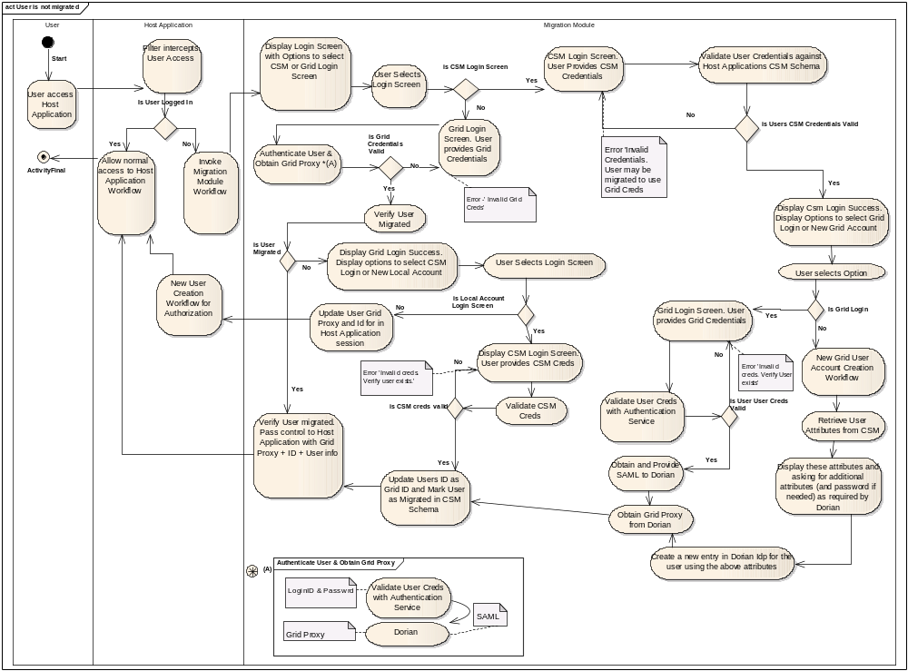
Figure 2: CGMM Activity Diagram

The migration module enables following workflow scenarios described in above activity overview:

- User logs in with CSM credentials

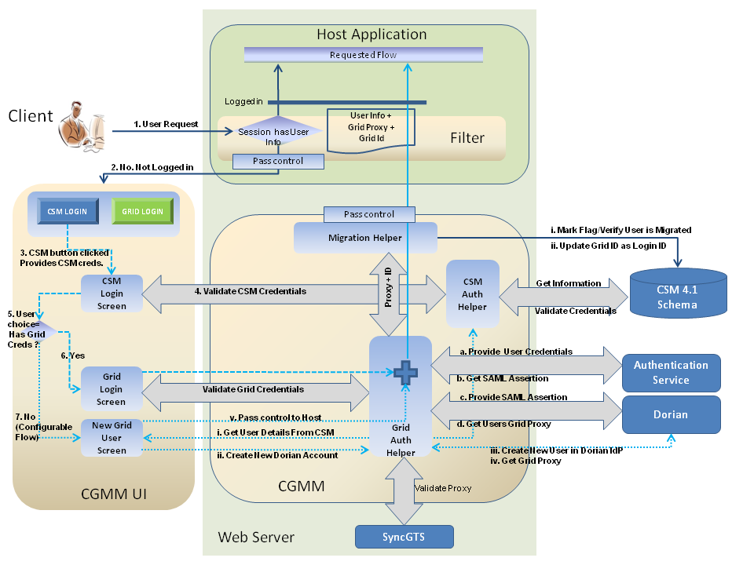
Figure 3: CSM Login Scenarios

- The user accesses any secured page on the Host web application
- The migration filter intercepts the Http request and determines user needs to log in.
- User selects CSM login screen and provides CSM credentials
- CGMM validates CSM credentials
- User selects Grid login screen or new Grid
- User with existing Grid credentials
  - CGMM asks the users to log in with their grid credentials.
  - Upon successful Grid authentication it retrieves the user’s proxy and the grid id.
  - CGMM updates the users local CSM Id with the Grid Id and marks the user as migrated in CSM Authorization Schema.
  - CGMM caches the proxy to be retrieved later by the host application via the filter
- User without existing Grid credentials
  - CGMM checks configuration to see if new Grid user creation workflow is enabled/disabled.
  - If the new creation workflow is enabled in the CGMM properties configuration.

    - CGMM retrieves user’s information from CSM.
    - CGMM prompts the user to provide any missing information and proceed to create a new user account in Dorian.
    - Upon successful creation of user, CGMM authenticates user, retrieves the user’s proxy and the grid id from Dorian.
    - CGMM updates the users local CSM Id with the Grid Id and marks the user as migrated in CSM Authorization Schema.
    - CGMM passes control to the host application and caches the proxy to be retrieved later by the host application via the filter

  - If the new creation workflow is disabled in the CGMM properties configuration.

    - CGMM passes control to the host applications public home page indicating a new Grid user account should be created.

In either of the above two cases the control is transferred back to the Host applications home page. The Host application can retrieve user’s Grid Id and Proxy from the session (which is set by the Filter) indicating a successful authentication and log the user into the application.

- User logs in using Grid credentials

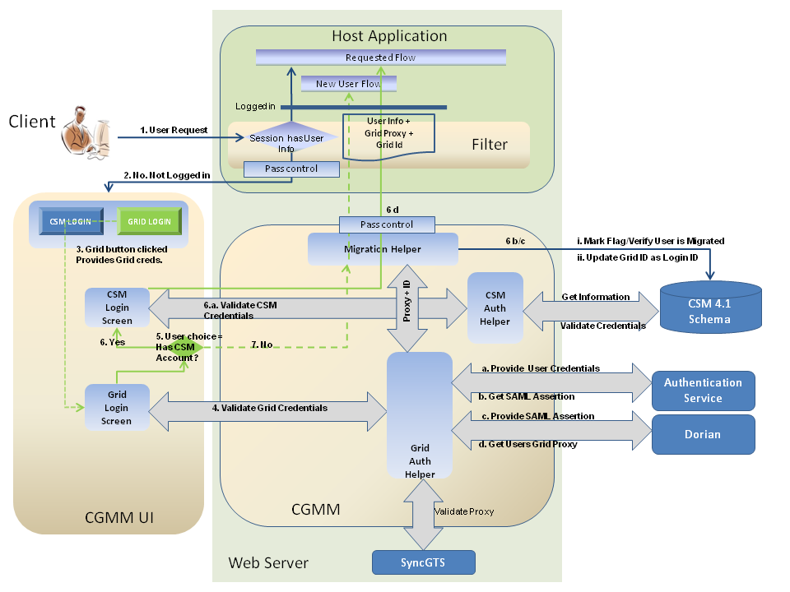
Figure 4: Grid Login Scenarios
- The user accesses any secured page on the Host web application
- The migration filter intercepts the Http request and determines user needs to log in.
- User selects Grid login screen and provides Grid credentials
- CGMM validates Grid credentials
  - Provide user credentials
  - Get SAML Assertion from Authentication Service
  - Provide SAML assertion to Dorian
  - Get users Grid proxy from Dorian
- User selects CSM login screen or new CSM user creation workflow.
- User with existing CSM account
  - CGMM asks the users to log in with their CSM credentials.
  - Upon successful CSM authentication. CGMM updates the users local CSM Id with the Grid Id and marks the user as migrated in CSM Authorization Schema.
  - CGMM caches the proxy to be retrieved later by the host application via the filter
  - CGMM passes control to the host application user home page.
- User without existing CSM account
  - CGMM caches the Grid proxy to be retrieved later by the host application via the filter
  - CGMM passes control to the host applications new CSM user creation page.

- Subsequent Login of the migrated users

Upon successful login, the control is transferred back to the login module of the host application. The Host application can retrieve user’s Grid Id and Proxy from the session indicating a successful authentication and log the user into the application.

CGMM User Interface Workflow

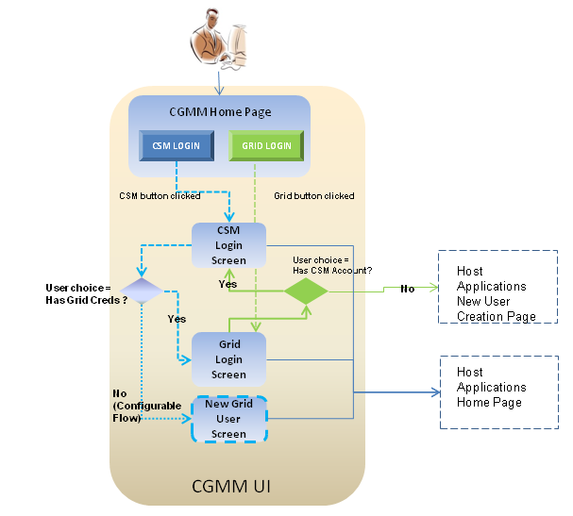
Figure 5: CGMM User Interface workflow

CGMM User Interface will be built based on the NCICB UI Library template. As part CGMM configuration the Host application has the option of disabling the new Grid user workflow of CGMM User interface. The New Grid User Screen can be configured and feature can be turned off. Hence the New Grid User screen is shown as optional.

The Configuration section shows how the New Grid User creation workflow can be turned off via a configuration setting in the CGMM configuration file.

Interaction with GAARDS

The CGMM interactions with GAARDS components are primarily for authenticating Grid users, obtaining Grid proxy, and creating new user accounts. The underlying Trust fabric management is done by SyncGTS.

SyncGTS

The Host application configures the CGMM to use SyncGTS. If CGMM is configured and SyncGTS is enabled, the Sync GTS daemon will keep the Host application in sync with the Grid Trust Fabric and update the CRL’s accordingly.

Interaction with Authentication Service

The Host application configures the CGMM configuration file with a list of Authentication Services against which the user Grid credentials can be validated. The configuration details are available in Configuration section. CGMM presents this list to the user on the Grid Login page.

Based on the workflow scenarios mentioned in CGMM Workflow section, the user has to be authenticated by the Authentication Service chosen by the user on the CGMM Grid Login Screen.

Following is the interaction of CGMM with Authentication Service.

- User is on the CGMM Grid Login page.
- User provides the Grid Login Id and Password.
- User selects an Authentication Service from the presented list of IdPs on the Grid Login page.
- User clicks the Login button.
- CGMM retrieves the URL of Authentication Service from the Grid Login page.
- CGMM invokes the Authentication Service selected by the user and passes provided credentials.
- If the user credentials are valid, the Authentication Service returns a SAML Assertion.
- If the user credentials are invalid, the Authentication Service throws an Exception.

Interaction with Dorian

The Host application configures the CGMM configuration file with the Authentication Service(s) and their respective Dorian URLs. The configuration details are available in section 5. The CGMM invokes the Dorian service to obtain Grid proxy and Grid Id. The Grid proxy is necessary to pass control to the Host application.
The CGMM uses Dorian to host all the users migrated from individual local host application instances which are not associated to any other IdPs.

Based on the scenarios mentioned in CGMM Workflow Section 3.3, the following are the resulting scenarios for which control is passed between CGMM and Dorian

- Scenario 1: CGMM gets SAML Assertion from Authentication Service indicating user is authenticated.
  - CGMM authenticates user with grid credentials against the Authentication Service
  - CGMM gets the SAML from Authentication Service
  - CGMM passes the SAML assertion and Authentication Service URL to Dorian
  - CGMM obtains users Grid proxy and retrieves Grid Id from Dorian.
  - CGMM passes control to appropriate Host web application page depending on whether user has local account or not.
- Scenario 2: User doesn’t have Grid Account
  - CGMM determines if the New Grid User Creation workflow is enabled via the CGMM configuration file.
  - Grid user creation workflow is enabled
    - CGMM retrieves user’s information from CSM schema.
    - CGMM asks user to provide missing information (and new password) to create an account in Dorian IdP.
    - CGMM creates a new user entry in Dorian IdP for the user using above information.
    - CGMM authenticates the newly created user.
    - CGMM obtains Grid proxy and Grid Id by invoking Dorian
    - If configured, CGMM validates Grid proxy with SyncGTS
    - CGMM passes control to appropriate Host applications user home page.

  - Grid User creation workflow is disabled
    - CGMM passes control to Host applications public home page.

Validation of Proxy

The validation of Grid proxy is performed in the following scenario.

Scenario: CGMM gets Grid proxy from Dorian indicating user is authenticated
  - CGMM obtains Grid proxy and Grid Id by invoking Dorian
  - CGMM validates the Grid proxy against the updated CRL’s.
  - If Grid proxy is valid, the CGMM continues with its workflow
  - If Grid proxy is not valid, the CGMM indicates authentication failure and
continues with Grid Login credentials failure flow by showing appropriate error message to the user.

Interaction between CGMM and Host application

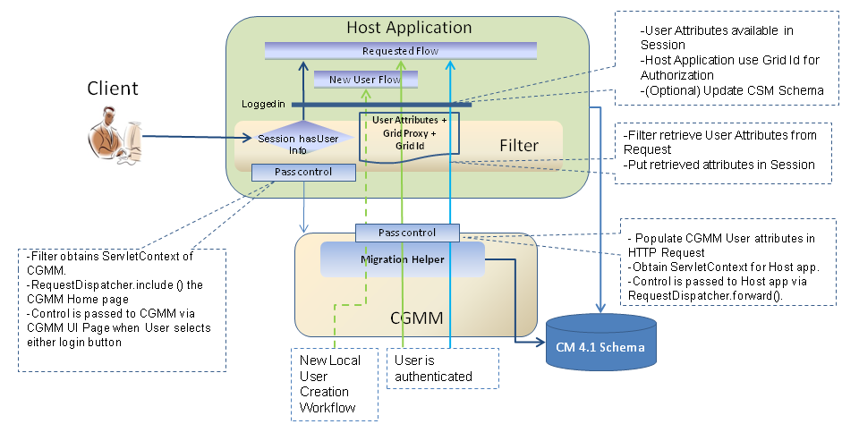
Figure 6: Interaction between CGMM, Filter and Host application

As part of the solution, based on the requirement of seamless integration, the Migration Module and Host application pass control to and fro seamlessly without user intervention. This integration allows the Migration Module to become part of the Host application and takeover its authentication workflow. The Migration Module is intended to implement the Authentication workflow indefinitely for the life of the Host application until the Host application is refactored to handle GAARDS based authentication.

To allow passing of control between Host application and CGMM, the Host web application is configured to enable a Servlet Filter configured in the web.xml and provide CGMM configuration file configuration with required Host application details. The filter implementation class CGMMMigrationFilter is provided by CGMM. The CGMMMigrationFilter implements javax.servlet.Filter interface.

Interaction between Filter and Host application

The CGMMMigrationFilter inspects all user http requests and checks if it is a new Session or user is logged in. To verify if user is logged in or not, the Migration Filter looks for user attributes in the Session.

If user attributes are not available in the session then the Filter passes control to the CGMM. The Migration Filter obtains the Servlet Context of CGMM and uses the RequestDispatcher.include() to show the CGMM home page. The CGMM web application gets control as the user selects a login button.

If the user is logged in and user attributes are available in session, the migration filter gives up control next filter in chain and hence to the requested workflow of the host application.

Interaction between CGMM and Filter

CGMM and Filter interaction occurs at the time of passing control from CGMM to Host application and vice versa. The interaction happens under following scenarios.

Scenario 1: User is logged in.

No interaction between CGMM and Filter

Scenario 2: User is not logged in, user does not have valid local or Grid credentials

This scenario occurs when the user fails to authenticate against either CSM and/or Grid.

Pass of Control from migration filter to CGMM
  - The user accesses any page on the Host web application.
  - The Servlet request is filtered by Host application’s CGMMMigrationFilter.
  - CGMMMigrationFilter determines it’s a new Session or user is not logged in.
  - CGMMMigrationFilter obtains the Servlet Context of CGMM.
  - CGMMMigrationFilter obtains the RequestDispatcher Object from Servlet Context and invokes the RequestDispatcher.include() method to pass control to CGMM home page
  - CGMM gets control when user selects a workflow on CGMM home page.

Pass of Control from CGMM to migration filter

No interaction between CGMM to migration filter in this case. The filter is invoked only for the secured workflows of the host application. The Host applications public home page is not secured and hence filter doesn’t control.

Scenario 3: User is not logged in, user has local account and is authenticated by Grid

This scenario occurs when the user has local account and a valid Grid account. The user is authenticated with CSM and Grid credentials. The passing of control from Host application to CGMM is same as Scenario 2.

Pass of Control from migration filter to CGMM

Refer Pass of control from migration filter to CGMM in section 3.5.2.2

Pass of Control from CGMM to migration filter

  - CGMM authenticates user, migrates user and obtains Grid proxy.
  - CGMM obtains the Servlet Context of the Host web application.
  - CGMM puts the Grid proxy and remaining user information as attributes of the Request object.
  - CGMM invokes the RequestDispatcher.forward() method to pass control to Host web applications user home page
  - The Host application’s CGMMMigrationFilter inspects the request and obtains the user attributes from Request.
  - Host’s CGMMMigrationFilter stores the user attributes and Grid proxy in Session.
  - The Host web application uses the Grid Id for Authorization.
  - The control is passed to Host web application.

Scenario 4: User doesn’t have local account and is authenticated by Grid

This scenario occurs when the user does not have a local CSM account and only has valid Grid credentials. The user is authenticated with Grid credentials only. The passing of control from Host application to CGMM is same as Scenario 2.

Pass of Control from migration filter to CGMM

Refer Pass of control from migration filter to CGMM in section 3.5.2.2

Pass of Control from CGMM to migration filter
  - CGMM has Grid proxy and Grid Id of the authenticated Grid user.
  - CGMM obtains the Servlet Context of the Host web application.
  - CGMM puts the Grid proxy and Grid Id as attributes of the Request object.
  - CGMM obtains the RequestDispatcher Object from Servlet Context and invokes the RequestDispatcher.forward() method to pass control to Host web applications New User creation page.
  - The filter inspects the request, obtains Grid proxy and Grid Id and stores info in Session.
  - The filter gives up control and passes control to the Host web application.

Session Attributes

The passing of control to Host application’s secured workflow is intercepted by the CGMMMigrationFilter Filter. The CGMM Filter inspects the incoming request for CGMM provided user attributes.

The Host application can use the authenticated user’s information that is populated by the CGMM Filter in the Session. Following is the list of attributes which provide values for the user attribute:

Session Attribute Name | Information
CGMM_GRID_IDENTITY | User’s Grid Identity
CGMM_FIRST_NAME | User First Name
CGMM_LAST_NAME | User Last Name
CGMM_EMAIL_ID | User’s Email Id
CGMM_GRID_CREDENTIAL | User Grid Credential (Grid proxy)

Required changes in Host Application

The Host application should make appropriate modifications to their source code to incorporate the above mentioned Session attributes. By doing so the Host application can determine whether or not a User is authenticated. The authenticated Users information can then be utilized by the Host application to perform authorization and other business logic.

The Host application design and internal changes are beyond the scope of this design document.

Configuration
This section provides details regarding the configurable aspects of the CGMM.

Overview

The configurations for CGMM are the following:

- CGMM configuration file: cgmm-properties.xml
  - List of supported IdPs and their Dorian URLs ( Authentication Service URLs and Dorian URLs for each Authentication Service)
  - Host application properties – Context Name, Logos, error messages text, URLs.
  - New Grid user creation workflow properties
  - SyncGTS startup
- Login-config – Entry for LoginModule(s) for CSM authentication.
- JNDI Data source – Pointing to the Host applications CSM Schema
- Sync-description.xml – SyncGTS configuration file.

CGMM Feature configuration

The Migration Module is designed to incorporate unknown Host application workflows by allowing configurable CGMM feature enabling/disabling. CGMM is also designed to be flexible to incorporate multiple sources of authentication. As part of the technical requirements, CGMM features can be managed via CGMM configuration file. Currently the CGMM feature management includes the following:

- Configurable ‘New Grid User workflow’ option to the user

The New Grid User creation workflow is a configurable feature of CGMM. It can be configured to be enabled or disabled via the CGMM properties configuration file. The CGMM configuration properties to enable/disable the workflow include – 'Grid User Creation Disabled’ and ‘grid user creation disabled redirect url’.

Depending on the Host application the feature can be disabled. If this workflow is disabled, the user will not be provided an option to create a new grid user. The user will be asked to provide grid credentials on the Grid Login page. If the user does not have Grid credentials then he/she will have the option to be redirected to the configured Host application page.

If this workflow is enabled, the user will be able to create a new Dorian account and obtain Grid proxy. Once the user is authenticated using CSM credentials, the user will be provided an option to either authenticated using Grid credentials or create a new Grid account. This scenario is explained in the section Interaction of Migration Module with Dorian Service’.

- Configurable Host Home, Host New CSM User Workflow path

As part of the Host applications New CSM user creation workflow support, the CGMM properties configuration allows specifying the Host applications public home URL, new CSM user creation workflow URL.

User Interface Configuration

The CGMM User Interface will be built based on the NCICB UI Library template. The CGMM User Interface is made configurable to enable extending Host applications look and feel in the CGMM web pages. Following are the configurable aspects of the CGMM Web UI in the CGMM properties configuration.
  - Host Application Details
    - To allow display of Host application related information and URL’s for redirects.
    - CGMM Properties
      - Name of the Host application
      - Abbreviated or Short name of Host app.
      - Host application context name
      - Host application public home page URL

  - Logo
    - To allow display of host application logo on CGMM Screens.
    - CGMM Property: Host application Logo

  - CSM Login Button/Menu Text
    - To allow change of text for CSM Login Button/Menu on CGMM Home page.
    - CGMM Property: Menu CSM Value
  - Grid Login Button/Menu Text
    - To allow change of text for Grid Login Button/Menu on CGMM Home page.
    - CGMM Property: Menu Grid Value
  - Error Messages
    - To allow Host application related custom error messages for failed login attempts or other login related errors/exceptions.

GAARDS Configuration

As part of the GAARDS configuration the CGMM properties configuration allows specifying the List of Authentication Service s and their Dorian information. For Authentication Service the configuration allows specifying the Name, URL and Dorian Information.

The Dorian information configuration allows specifying the Dorian Service URL, Proxy details such as – lifetime-hour, lifetime –minutes, lifetime-seconds, etc.

Sync GTS configuration

As part of the SyncGTS configuration, the CGMM properties configuration allows the start-auto-syncgts property. If this property is set the CGMM will programmatically start a Servlet on startup to initialize SyncGTS.

Database Change

The CSM Authorization Schema is modified to track CSM users that are migrated with Grid Id. To migrate an existing CSM user to Grid user, the CGMM will update
a) The CSM_USER.LOGIN_NAME field with user’s Grid ID and
b) Set MIGRATED_FLAG to 1.

If MIGRATED_FLAG field value is 0, the CGMM will consider the user as CSM user.
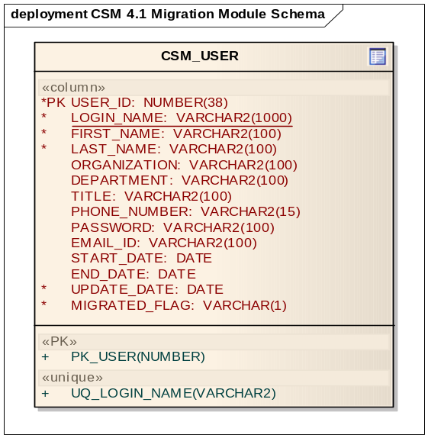

Deployment

Deployment Diagram
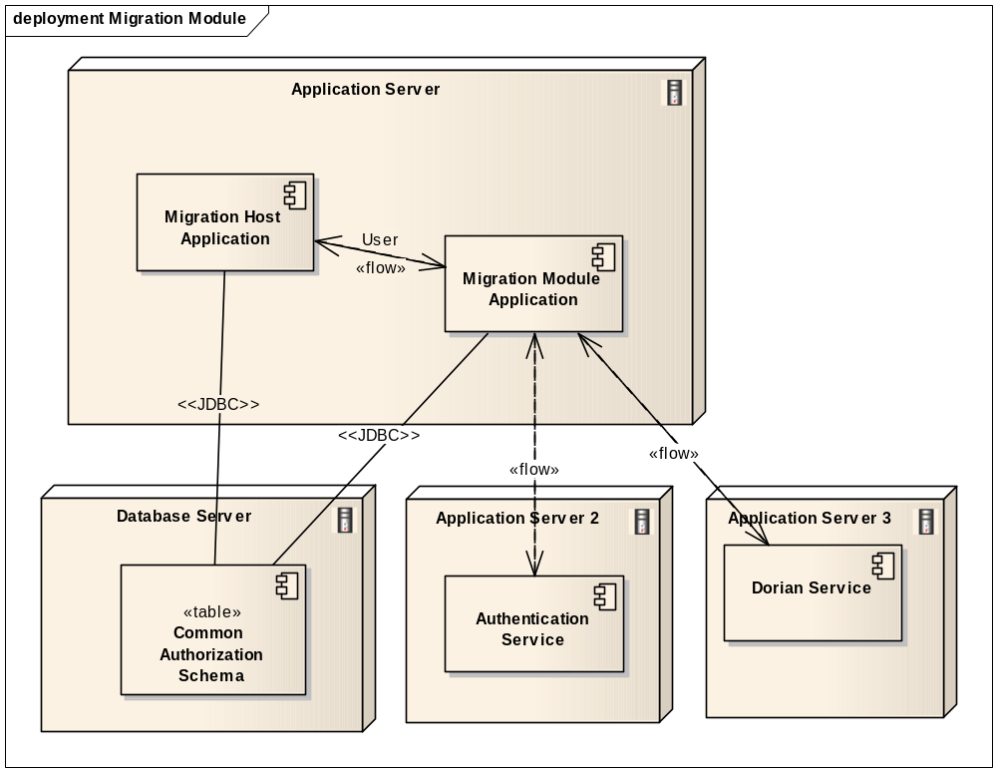
Figure 7: Deployment Diagram

The deployment diagram shows the CGMM and Host application are deployed in the same Application Server. This is necessary to share Host web application and CGMM web applications Servlet Context amongst each other.

The Authentication Service and Dorian Services can reside on any server (same or any other). The Host application and CGMM application need access to the CSM Authorization Schema to perform local authentications and/or create local CSM accounts for users.

Deployment Considerations

The Migration Module and Host application will have to programmatically run Sync GTS to establish the Grid Trust Fabric.

The Migration Module will be deployed along with the Host application in its container. The Migration Module will use the Host applications Host credentials to access the Authentication and Dorian services.

Unit Testing

JUnit Test Cases
This solution requires integration with a Host web application and is also dependent on Grid Components that need to be deployed and be up and running. Hence automated HTTPUnits/JUnit will not be available.

Integration tests will be performed and provided for various flows and exceptions paths.

Test Case Scenarios
The test case scenarios will be developed in conjunction with the QA Team. Based on the initial design the overall test scenarios are as mentioned below. Note that based on data each of these scenarios can have multiple test cases

  - Testing users CSM Authentication
  - Testing users Grid Authentication
  - Testing new Grid user Creation
  - Testing CGMM and Host application interaction
  - Testing passing of authenticated users Grid Identity and Grid proxy to Host application

